White Paper

Is Our Current Flood Warning System Still Effective?
A Whitepaper on Why Upgrading to ALERT2 Flood Warning Network is a Necessity

http://elprotech.com
@ ELPRO Technologies. All Rights Reserved.

Abstract
In recent months, Australia’s Bureau of Meteorology (BOM)’s plan to upgrade the existing flood warning network software package Enviromon which supports ALERT (Automated Local Evaluation in Real Time) messaging to an ALERT2 messaging software platform has been much discussed throughout the country.
ELPRO Technologies (ELPRO) has been at the forefront of flood warning networks since they have supplied ALERT Field Stations, Repeaters, Receivers and Decoders for over 25 years. With over 5,000 sites with ELPRO installed, ELPRO can provide a reliable, secure and flexible ALERT2 upgrade path for new and existing users.
This white paper discusses the differences between the ALERT and ALERT2 messaging systems, and how ELPRO Technologies is providing leading ALERT to ALERT2 migration strategies for existing users.

Problem Statement
ALERT has undoubtedly contributed much to current flood warning system capabilities in Australia and North America. However, like any technology, it has an expiry date.
This is becoming undeniable as more and more networks are added and ALERT shows its age through its growing limitations.

Background
To fully appreciate the full scope of ALERT’s growing limitations, we must go back to how it began. The ALERT protocol was developed in the early 1970s in response to hydrologists in the United States seeking better ways to access hydrology and rainfall data. With it, they could efficiently estimate runoff and forecasting flood peaks. While the implementation of ALERT started in the late 1970s in the U.S., it wasn’t implemented in Australia on the BOM network of rainfall and stream gauging until 1985. BOM continues to use this same network up to today with more than 5,000 stations currently in service.1

Core Features of ALERT:
- Facilitated real-time reporting
- It operated over a VHF or UHF radio network which eliminated dependence on existing communications infrastructure which again was critical for remote sites
- It is commonly not stored in field instrumentation
- It is an open protocol – it can be collected by anyone listening on the transmission frequency
- Had very low power requirements meaning it could be both battery or solar powered which was suited to remote sites.

1 ELPRO Technologies sales data and ERRTS canister serial numbers

While ALERT was a major step forward, as with all technologies, as time wore on and networks were built out, users identified some opportunities for improvement.

Limitations of ALERT protocol:
- Limited error detection or forward error detection
- Gauges report independently with little or no regard for other traffic on the radio channel meaning that during a rain event, there is a possibility of contention in the network which may lead to the loss of some message types at the most critical times
- Unique sensor IDs are required limiting the number of gauges that can be included in a network
- Data in an ALERT payload is limited to an integer value between 0 and 2047, which can cause issues with data resolution
- Slow transmission rate (300 baud)
- No timestamp associated with the transmission

Solution
Subsequently, in 2006, work started on a more up-to-date ALERT protocol, simply known as ALERT2. The BOM was a primary participant in the development of this updated protocol in conjunction with the NHWC (National Hydrological Warning Council). In the U.S., adoption of the ALERT2 protocol has been even more widespread with one-quarter of authorities starting some type of upgrade.
Furthermore, concurrent studies have identified overall very positive results due to the upgrade. The beneficial outcomes of ALERT2 can be summarized in the following table:

Technical Comparison of Protocols

Parameter | ALERT | ALERT2 | Real world implications
Transmission rate | 300 baud | 4800 baud | Larger scale networks with added reliability
Sensor ID pool | 8192 unique ID’s | 65,535 site  identifiers & 255 sensor ID’s within a site | Capable of supporting a larger network of sensors and adding other parameters e.g.  Temperature, Humidity
Data values | Integer only 0 to 2047 | Floating point and integer time- stamped data types  with up to 64bit resolution | Better data resolution and display
Error detection | Limited | Provides Forward Error Correction | Better data reliability

Media Access | Nil | TDMA (Time division multiple access) or ALOHA | Vastly improved percentage of messages successfully  transmitted, received and processed
Protocol flexibility | Fixed | Extensible | ALERT2 Protocol can be improved over time meaning that upgrades in future will  be incremental
Compatibility with other  standards | Nil | Transport of ALERT data  frames | Networks can be upgraded incrementally

Not only is it clear that ALERT2 is a significantly improved protocol in theory, field trials have also indicated significant performance improvements.
- The SEQWater study (Neilsen & Zucosky 2018) indicated that:
  - ALERT2 achieved a significantly higher proportion of successful transmissions than ALERT even though the ALERT2 repeater was situated at an inferior receiving location
  - Even during quiescent periods, ALERT2 experienced an increase in data reception of 15% from some field stations and all field stations exhibited some improvement in data reliability.
- The Harris County study of system performance during Hurricane Harvey (2017) (Hewitt, 2018) indicated that:
  - The event generated over 250,000 reports (123,000 rain and 64,000 stages) of which 99.2% successfully received and 99.4% were flagged as being good data
  - It was estimated that 87,500 (35%) of the reports would have been lost if the upgrade to ALERT2 was not undertaken
It is therefore clear that early trial data validates the theoretical benefits of ALERT2 over ALERT. For many authorities, the greatest benefit is the ability to increase the size of their sensor networks. However, this isn’t accounted for in these limited scope trial applications.

No Risk Upgrade Pathways
When moving to a new standard, one of the biggest perceived risks for network owners is that their existing investment will be rendered worthless. Fortunately, this is not the case at all with the ALERT to ALERT2 upgrade.
The structure of many existing ALERT networks in Australia is illustrated below. An ELPRO remote field station and repeater communicate back to base stations. Each field station is capable of operating as a transmitter only site or Transceiver for repeating remote field stations signals. A range of parts and support are offered for all these components by ELPRO Technologies. In most cases, the equipment has many years of use left. ELPRO Technologies new ERT-A2 product will support not only ALERT2 protocol but also the existing ALERT protocol keeping for backwards compatibility for systems not currently planned for upgrade allowing for future proofing of networks.

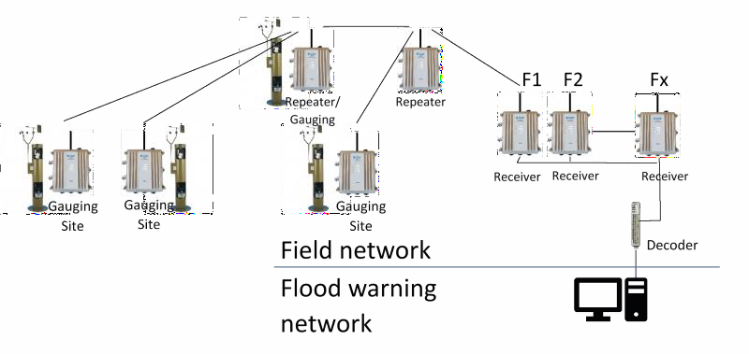

An upgrade to an existing network can be most economically made via the following process:
- Upgrade the base station to ALERT2 using an ELPRO ERT-A2 & 115E-2-ERT Receiver and Decoder
- Upgrade existing repeaters to the ELPRO ERT-A2
- Finally, over time upgrade the field stations using the ELPRO ERT-A2 connecting to the existing field sensors utilising the existing connections.
Once the upgrade is complete, the ELPRO ERT-A2 can act as either a Field Station, Repeater or Base Radio. The ELPRO ERT-A2 is an Intelligent Network Device with integrated radio and sensor I/O making it a flexible yet simple solution with backwards compatibility. Better yet, the backward compatibility of ALERT2 allows repeaters and base stations to transport ALERT messages, allowing for the staged migrations of networks. Even upgrading base stations and repeaters will provide a significant improvement in network capacity.

Conclusion
ELPRO Technologies fully supports the move to ALERT2. We believe this will be a plus for flood warning and meteorological authorities and ultimately for public safety. Furthermore, the upgrade pathway is not complex. ELPRO Technologies will continue to support the current extensive installed base of ERRTS equipment operating on the ALERT protocol still in use today. Likewise, with ALERT2 our full range of products can provide original network operators and integrators with the same end to end ERRTS solution that remains compatible with ALERT.

Marketing Resource Box

To further discuss the case presented in this white paper for upgrading from ALERT to ALERT2 or to talk about your specific upgrade requirements, please contact ELPRO Technologies on +61 7 3352 8600 or for North America +1 855 Hi ELPRO or you can email sales@elprotech.com.

References
Logan, J; Thompson, R and Gayl, I (2015). ALERT2™ transmission protocol, next- generation real-time hydrologic monitoring standard. Hydrology and Water Resources Symposium, Hobart, Tasmania, Australia.
Nielsen, S; Zucosky, M (2018). South East Queensland ALERT2 Trial. Increased reliability and accuracy of flood warning data. AHA Conference, Canberra, ACT, Australia.
Hewitt, G (2018). Before, During, and After Hurricane Harvey: Performance of an ALERT2TM Flood Warning System during a Category 4 Hurricane

